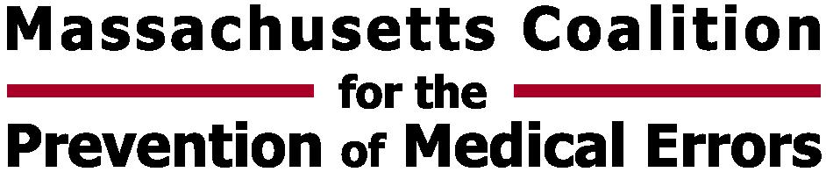
  Massachusetts Department  of Public Health | Betsy Lehman Center for Patient Safety  and Medical Error Reduction

IMPROVING HAND HYGIENE:
A SYSTEMS APPROACH
April 10, 2008

PACKET CONTENTS
Additional Resources-in this packet
Hand Hygiene at Massachusetts General Hospital Because we care: Staff Education Booklet
Hand Hygiene at Massachusetts General Hospital Because we care: Staff Education Training Slides
IHI How-to Guide: Improving Hand Hygiene
IHI Model for Improvement

Other Resources Provided
Ontario Just Clean Your Hands Implementation Guide
Ontario Just Clean Your Hands Four Moments for Hand Hygiene Card
Ontario Just Clean Your Hands Toolkit Crosswalk

Web Links
www.justcleanyourhands.ca
www.cdc.gov/handhygiene
www.ihi.org

